Palaeoenvironmental reconstruction of the Kovin lignite deposit, Serbia

D. Mitrović¹, N. Đoković¹, D. Životić*², A. Bechtel³, K. Stojanović⁴

¹ University of Belgrade, IC of the Faculty of Chemistry, Studentski trg 12-16, 11000 Belgrade, Serbia
² University of Belgrade, Faculty of Mining and Geology, Đušina 7, 11000 Belgrade, Serbia
³ Montanuniversität Leoben, Department of Applied Geoscienes and Geophysics, Peter-Tunner-Str. 5, A-8700 Leoben, Austria
⁴ University of Belgrade, Faculty of Chemistry, Studentski trg 12-16, 11000 Belgrade, Serbia
e-mail: dragana.zivotic@rgf.bg.ac.rs, ksenija@chem.bg.ac.rs

Abstract

The Upper Miocene (Pontian, around 6 Ma) coal-bearing sediments in the Kovin deposit (Serbia) are part of the “Banat-Morava” depression in the Pannonian Basin System and consist of fresh water clastic sediments, sand and clay, with three coal seams. Average huminite reflectance is 0.29±0.03 %. Comprehensive petrological and organic geochemical study was performed on lignites from the “B” field, Kovin deposit, originating from two boreholes from all three coal seams (depth interval 22.5-116.5 m).
The ternary diagram based on maceral composition indicates that peat was accumulated under anoxic to dysoxic conditions (Fig. 1). Peat-forming vegetation comprised of both reed and wood species. However, data from Fig. 1 suggest that samples differ according to the contribution of these two types of precursor vegetation. Tissue Preservation (TPI) and Gelification Indices (GI) (Diessel, 1992) as well as Groundwater Influence (GWI) and Vegetation Index (VI) (Calder et al., 1991; Diessel, 1992) are applied to further assess peat-forming conditions. The TPI values of the samples range between 0.33 and 4.17, which indicates variable organic matter (OM) preservation. The GI values range between 0.52 and 9.53 pointing to low to relatively high gelification of the OM. The values of VI range from 0.30 to 4.24 suggesting variable contribution of herbaceous peat-forming plants and arboreal vegetation, although average value for VI reaching 1.46 indicates the prevalence of the later. The GWI values range between 0.45 and 3.36. The GWI shows that peat was formed under ombrotrophics to mesotrophic conditions with fluctuations in water level.
Maceral composition implied slight variations in the precursor vegetation and redox conditions during peat accumulation. However, any clear separation of the samples within the boreholes and coal seams is not observed, suggesting cyclic and relative uniform repetition of the palaeo-conditions during the formation of all three coal seams. Concerning certain adversities of the above mentioned facies parameters, which are mainly based on origin and transportation of macerals, biomarker assemblages and stable carbon isotope proxies of individual compounds were further studied in detail.
Diterpenoids are main constituents of both saturated and aromatic fraction, indicating significant contribution of gymnosperms to the peat-forming vegetation. Pimarane and 16α(H)-phyllocladane are dominant by far in the saturated fraction of all investigated samples suggesting gymnosperm families Taxodiaceae, Cupressaceae, Araucariaceae, Phyllocladaceae and Pinaceae (Otto, Wilde, 2001). The δ¹³C values of diterpenoids, beyerane, pimarane and 16 α(H)-phyllocladane ranged from -24.32 to -27.27 ‰, -25.42 to -27.43 ‰ and -26.19 to -27.75 ‰, respectively, indicating mutual gymnosperm sources. Content of aromatic triterpenoids varies from low to moderate, implying variable contribution of angiosperms. Prevalence of odd long-chain homologues, maximizing at C₂₉ or C₂₇ is obvious in the n-alkane distribution of all samples. The δ¹³C values of odd n -alkanes C₂₅-C₃₃ (from -27.74 to -33.38 ‰) generally fall within the range for bulk carbon of C₃ higher plants. The variations of δ¹³C values of n-alkanes are consistent with observation derived from maceral analysis (Fig. 1) and imply that beyond woody vegetation, herbaceous also have contributed to peat formation. A general trend of increasing ¹³C depletion with chain length is apparent for the C₂₅-C₃₁ odd n-alkanes, followed by slight decreasing from C₃₁ to C₃₃ odd n-alkanes. Slight enrichment of C₂₅ n-alkane in ¹³C in part can be attributed to contribution of ¹³C enriched aquatic macrophytes, consistent with average P_{aq} value of 0.33. The hopanoid composition of saturated fraction is characterized by the presence of 17α(H)21β(H), 17β(H)21α(H) and 17β(H)21β(H) compounds with 27-32 carbon atoms with the exception of C₂₈ homologues. The hopanoid distribution is dominated by C₂₇ 17β(H)-hopane, C₃₀ hop-17(21)-ene, C₂₉ 17β(H)21β(H)-hopane or C₃₁ 17α(H)21β(H)22(R)-hopane, suggesting differences in microbial species. It is confidently confirmed by notable differences in δ¹³C of individual hopanoids (even more than 20 ‰). However, as in case of petrogrpahic analysis, any regularity between biomarker patterns and borehole or coal seam was not observed. This result argues in favour of cyclic and relative uniform repetition of the palaeo-conditions during the formation of all three coal seams.

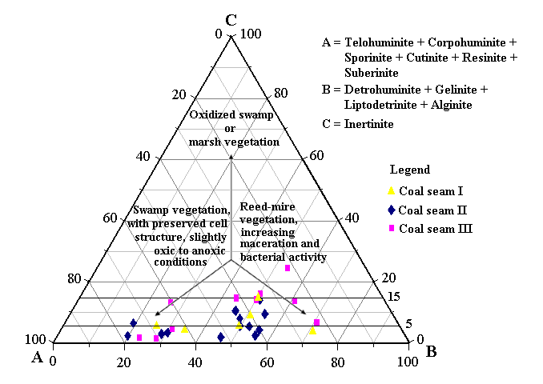

Fig. 1. Estimation of the palaeoenvironmental conditions based on maceral analysis.

Calder, J., Gibling, M.,Mukhopadhyay, P., 1991. Peat formation in a Westphalian B piedmont setting, Cumberland Basin, Nova Scotia; implications for the maceral-based interpretation of rheotrophic and raised paleomires. Bulletin de la Société Géologique de France 162, 283-298.
Diessel, C.F.K., 1992. Coal-bearing depositional systems. Springer, Berlin, 721 pp.
Otto, A., Wilde, V., 2001. Sesqui-, di-, and triterpenoids as chemosystematic markers in extant conifers – a review. Botanical Review 67, 141-238.

