Pyrolysis of lignite, HDPE and lignite/HDPE mixture

I. Kojić¹, G. Gajica², D. Životić*³, A. Bechtel⁴, K. Stojanović⁵

¹ University of Belgrade, IC of the Faculty of Chemistry, Studentski trg 12-16, 11000 Belgrade, Serbia
² University of Belgrade, IChTM, Center of Chemistry, Njegoševa 12, 11000 Belgrade, Serbia
³ University of Belgrade, Faculty of Mining and Geology, Đušina 7, 11000 Belgrade, Serbia
⁴ Montanuniversität Leoben, Department of Applied Geoscienes and Geophysics, Peter-Tunner-Str. 5, A-8700 Leoben, Austria
⁵ University of Belgrade, Faculty of Chemistry, Studentski trg 12-16, 11000 Belgrade, Serbia
e-mail: dragana.zivotic@rgf.bg.ac.rs, ksenija@chem.bg.ac.rs

Abstract

Plastic hydrocarbon materials such as polyethylene and polypropylene can be the source of hydrogen during the pyrolysis of hydrogen depleted natural products such as lignite organic matter. In this study the mutual impact of lignite and high density polyethylene (HDPE) during open system pyrolysis was investigated.
Lignite, having a total organic carbon (TOC) content of 44.32 %, Hydrogen Index of 157 mg HC/g TOC and Production Index of 0.03 from the Smedervsko Pomoravlje field (Kostolac Basin, Serbia) was used. Plastic bag for food packing was used as a source of HDPE. Pyrolysis of lignite, HDPE, and their mixture (mass ratio 1:1) was performed in open system pyrolysis (Pyrolyser, Model MTF 10/15/130 Carbolite, UK) under a nitrogen atmosphere during 4 hours at three temperatures 400, 450 and 500 ºC. The temperature range between 400 and 500 ºC was chosen, concerning the thermogravimetric properties of HDPE (Ray, Coney, 2012) and fact that coal exists in a plastic state under such conditions (Ishaq et al., 2006). Liquid pyrolysis products were extracted using hot chloroform. The solid residue was dried and weighed, whereas yield of gas was calculated as: 100 % – (yield of liquid pyrolysate + yield of solid residue). After precipitation of asphaltenes by n-heptane liquid pyrolysates were separated into saturated, aromatic and polar fractions using column chromatography. Saturated and aromatic fractions were analyzed by gas chromatography mass spectrometry (GC-MS) technique.
Yields of pyrolysis products relative to TOC content are shown in Fig. 1. As expected increasing the temperature resulted in increase of conversion of all three substrates into liquid and gaseous products. However, the increase is much more prominent for HDPE and lignite/HDPE mixture, than for lignite alone. The evaluation of the interactions between lignite and HDPE has been carried out by comparing the experimental yield of the pyrolysis of the mixture lignite/HDPE and theoretical/calculated yield = (yield of lignite + yield HDPE)/2 (Fig. 1). At temperature of 400 ºC the experimental and calculated yields are very similar, indicating no synergetic effect between lignite and HDPE. This result can be attributed to relatively high thermal stability of HDPE up to 400 ºC which is followed by an abrupt single mass loss step between 400 ºC and 500 ºC (Ray, Coney, 2012). However, at temperatures of 450 ºC and particularly 500 ºC experimental yields of liquid and gas products are obviously higher than theoretical (Fig. 1), indicating synergetic effect between lignite and HDPE. At both, temperatures 450 ºC and 500 ºC where synergetic effect was observed, difference between the experimental yields and theoretical yields is higher for gaseous than for liquid products.
Co-pyrolysis of lignite/HDPE mixture demonstrated positive impact on liquid pyrolysate composition, which is expressed through the lowering of asphaltene content and rise of hydrocarbons (HC) content in relation to pyrolysis of lignite alone. For example increase of temperature from 400 ºC to 500 ºC resulted in negligible increase of HC content in the liquid pyrolysate of lignite, whereas the same temperature change increases the content of HC in liquid pyrolysate of lignite/HDPE mixture ~ 3.5 times. As it was expected liquid pyrolysate of HDPE itself obtained in all experiments comprises exclusively HC.
The main constituents of saturated fractions of all liquid pyrolysates are n-alkanes and terminal n-alkenes. n-Alkanes are identified in range from C₁₃ to C₃₇. n-Alkane patterns of all samples show distribution typical for oils with equal abundance of odd and even numbered homologues. Consequently, Carbon Preference Index (CPI) values in all pyrolysates are close to 1 (0.98-1.10), showing negligible decrease from lignite pyrolysates to HDPE and mixture lignite/HDPE. Lignite pyrolysates at all three temperatures are characterized by prominent n-alkanes in C₁₈ to C₂₅ range, whereas in HDPE and lignite/HDPE pyrolysates domination of n-alkanes in range from C₁₆ to C₁₉ is observed. n-Alkenes are identified in range from C₁₃ to C₃₁ and have almost identical distribution as n-alkanes. n-Alkylcyclohexanes ranged from C₁₄ to C₂₆ (total number of carbon atoms) are present in all samples. C₂₃ n-alkylcyclohexane is the most abundant in lignite pyrolysates, whereas in pyrolysates of HDPE and lignite/HDPE the prevalence of C₁₆ and C₁₈ n-alkylcyclohexanes is observed.
Aromatic fractions of lignite and lignite/HDPE pyrolysates are also comparable with aromatic fraction of crude oils and consist of n-alkylbenzenes, n-alkyltoluenes, dimethyl-, trimethyl- and tetramethyl-naphthalenes, phenathrene, fluorene, pyrene, chrysene, dibenzofuran and their methylated derivatives, showing relatively similar patterns in all samples. However, values of maturity parameters based on naphthalene, phenathrene and chrysene derivatives are slightly higher in pyrolysates of lignite/HDPE than in lignite pyrolysates at all temperatures, indicating the influence of HDPE on maturity changes of lignite organic matter. n-Alkylbenzenes and n-alkyltoluenes represent exclusive aromatics found in HDPE pyrolysates, most probably formed via dehydrocyclization of reactive radicals. Like for n-alkanes, distributions of n-alkylbenzenes are characterized by equal abundance of odd and even numbered homologues in all samples.
The results obtained in this study indicate that co-pyrolysis of lignite and HDPE seems to be an attractive way for their transformation into valuable products.

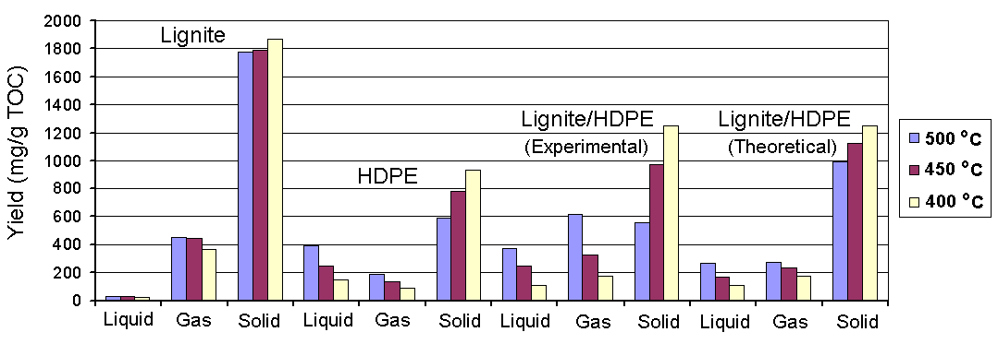

Fig. 1. Yields of the pyrolysis products.

Ishaq, M., Ahmad, I., Shakirullah, M., Arsala Khan, M., ur Rehman, H., Bahader, A., 2006. Pyrolysis of some whole plastics and plastics–coal mixtures. Energy Conversion and Management 47, 3216-3223.
Ray, S., Cooney, R.P., 2012. Thermal Degradation of Polymer and Polymer Composites. In: Kutz, M. (Ed.), Handbook of Environmental Degradation of Materials (Second Edition). Elsevier, Oxford, pp. 213-242.

